WHITE TIGER
feature-length motion picture
Russia, 2012, color, 104 min., aspect ratio 1.85:1, Dolby Digital
End credits and logos
Scriptwriters Aleksandr Borodyanskiy, Karen Shakhnazarov
Directed by Karen Shakhnazarov
Director of Photography Aleksandr Kuznetsov
Cinematography Alik Tagirov
Production Design Sergey Fevralev
Artistic Design Irina Ochina
Composer Yuriy Poteenko, Konstantin Shevelev
Costume Designers Dmitriy Andreev, Vladimir Nikiforov
Make-up Design Nina Kolodkina
Sound Design Gulsara Mukatayeva
Editor Irina Kozhemyakina
Producers Karen Shakhnazarov, Galina Shadur
Cast:
Naidyonov Aleksey Vertkov
Fedotov Vitaly Kishchenko
Zhukov Valery Grishko
Smirnov Dmitri Bykovsky
Sharipov Gerasim Arkhipov
Kriuk Aleksandr Vakhov
Berdyev Vitaly Dordzhiev
Hospital Director Vladimir Ilyin
Hitler Karl Kranzkowski
Keitel Christian Redl
Stumpff Klaus Grünberg
Friedeburg Vilmar Bieri
First Prisoner Dirk Martens
Second Prisoner Michael Schenck
Including: V. Chankin, P. Chukreev, V. Ageev, M. Shashlova, S. Eventov, A. Ermakov, O. Tsink, S. Vlasov, M. Bitiukov, R. Tolokonnikov, A. Kazakov, A. Alekseev, P. Vybornov, M. Karpova, O. Semina, V. Garshin, A. Semerov, D. Yashnov, V. Kuznetsov, P. Zabotkin, I.Lomovtsev, M. Karanda, D. Malikov, V. Kartashov, R. Ushakov, Yu. Pronin, M. Feoktistov, I.Uryvaev, V. Solovyov, V. Repyov, A. Duda, G. Bagrov, S. Rozhkov, K. Konov, V. Suslin.

Director of the picture A.Karpushin
Administrative group E. Dukarevich, A. Longinova, A. Kovalenko, L. Grebenkina, V. Rubtsov, S. Konstantinov, V. Ilyushkin,
Director of the Tank Group Principal Military Consultant V. Safonov
Director R. Abdullaev
Direction Group I. Lavrentieva, M. Levitin, E. Duplyakina, I. Shakhnazarov, V. Suslin,
Props A. Batorov, R. Ushakov, N. Batorova,
Set Decoration M. Kozlov, K. Kakovkin, M. Kopytova, P. Morozov, Yu. Allyonov
Foremen of Location filming V. Kotov, V. Namesnikov
Painter V. Orlov
Stage direction R. Antipin, A. Matveenko, E. Stepanyan, V. Nikolaenko, E. Podgorodetskiy
Consultants M. Kolomiets, A. Zhukov
Cameraman D. Chabanko
Assistant Cameraman D. Novikov
Film crew S. Matiukhin, D. Novikov, A. Konyov, I. Tokarev, A. Kriukov, E. Musin, A. Mikhalychyov
Assistants:
For the Sound director A. Kipriyanov, A. Romanov
For Make-up S. Bulychyova, L. Petrenko, M. Rozhkova, K. Evtiushina
Lighting Engineer Yu. Leikin
Lighting technicians A. Yakubov, S. Barmin, D. Roldugin, R. Makeev
Costumers N. Katulkina, D. Baranov, O. Maksimova, A. Sergeeva
Texture artist M. Martyanova
Props M. Dzino, S. Filimonov, E. Solodkiy
Mechanics-Drivers L. Starodubtsev, I. Korkin, E. Noskov, D. Teplyakov
Special effects and Pyrotechnics OOO “Action S. F. ix”
Special Effects Direction I. Titov, I. Churinov,
Pyrotechnics A. Emelyanov, A. Aseev, P. Bulaev, V. Sergeev, S. Gorelov, M. Yakushov, E. Antonov, R. Pershin
Sound direction of the recording P. Shuvalov
Sound direction for music recording G. Papin, A. Levin
Recording of orchestral music under the direction of Igor Dronov
Digital Sound Editing I. Valiyev, A. Simonenko
Sound Effects P. Doreuli, A. Volodin
Sound design N. Trofimchuk, I. Kislova, N. Chashchina
Computer Graphics The Division of Computer Graphics of Mosfilm Cinema Concern
Editors of negatives E. Gorbunova, T. Sibelyova,
Color correction S. Mikhailenko
Comptroller G. Mozzhukhina
Accountants E. Agaltsova, N. Butykina
Equipment and model preparation D. Martinelli, T. Gavva, A. Bushuev, M. Kozlov, O. Panteleev
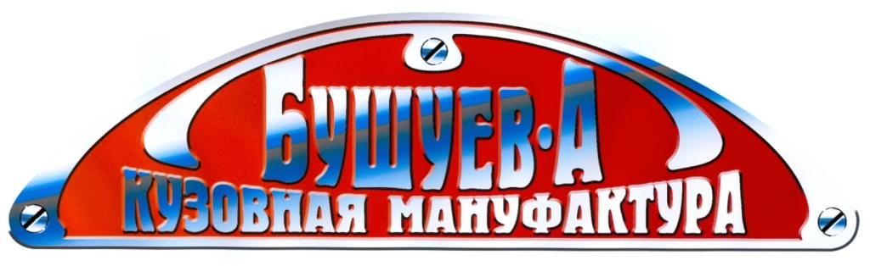
Prosthetic make-up, special effects, models The studio of Pyotr Gorshenin “Ef Iks Design Group Int”
The studio of Pyotr Gorshenin “Ef Iks Design Group Int”

Studio Director A. Abadaev,
Assistants N. Abramov, M. Bulanov, N. Goldov, T. Melkomova
“Studio of Prosthetic Make-up and Physical Special Effects “FX GRIM”
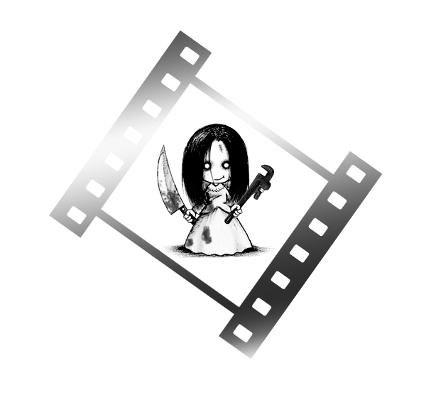
A. Plesovskiy, O. Vishnyakova, A. Aleksandrov, A. Khokhlov, V. Komardina, T. Trefilova
The Film Crew would like to thank the Ministry of Defense of the RF



The End
Copyright: The Cinema Concern “Mosfilm”, 2012
