STORMY NIGHT

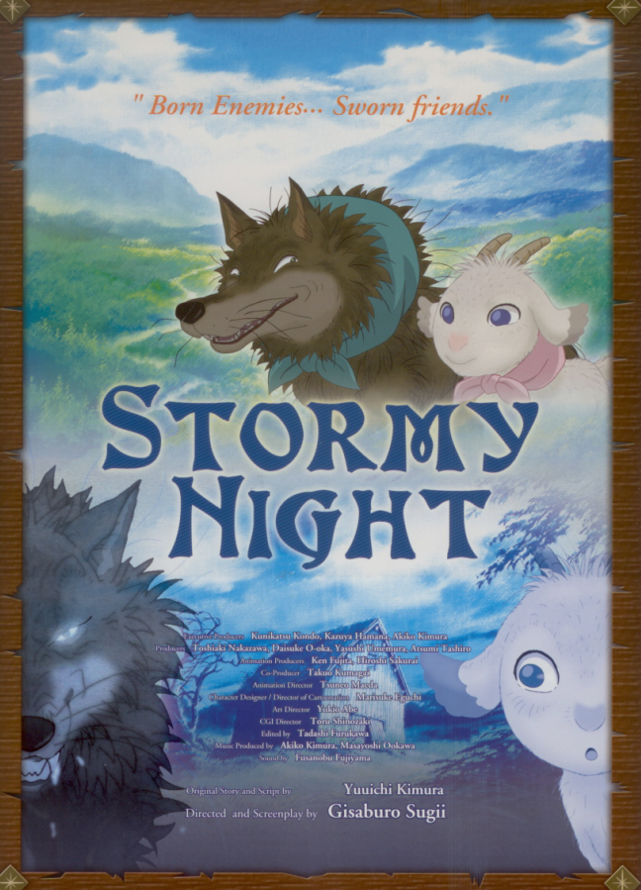

Director : Gisaburo SUGII

Duration : 90’

Production year : 2006

Genre : Animation – Drame/Aventure

Synopsis : Born enemies…sworn friends, Gav and Mei, a wolf and a goat, meet by chance developing a friendship that transcends the natural enmity between predator and prey.

The movie is based on Yuuchi Kimura’s best selling picture book.

It is directed by Gisaburo Sugii, one of Japan’s top directors of animation, who illustrated and directed many episodes of “Astroboy”.

