MOLLY MOON THE INCREDIBLE HYPNOTIST
BILLING BLOCK
24/04/15

AMBER ENTERTAINMENT PRESENTS A MOLLY MOON FILMS PRODUCTION IN ASSOCIATION WITH DROP OF WATER PRODUCTIONS
“MOLLY MOON AND THE INCREDIBLE BOOK OF HYPNOTISM ”
DOMINIC MONAGHAN LESLEY MANVILLE EMILY WATSON CELIA IMRIE ANNE-MARIE DUFF BEN MILLER SADIE FROST OMID DJALILI GARY KEMP TOM WISDOM
JADON CARNELLY-MORRIS AND JOAN COLLINS AND RAFFEY CASSIDY AS MOLLY MOON
CASTING JOHN HUBBARD ROS HUBBARD LINE PRODUCER MARK BIRMINGHAM CHOREOGRAPHER ANTHONY VAN LAAST MUSIC BY PETER RAEBURN
VISUAL EFFECTS SUPERVISOR BEN SHEPHERD COSTUME DESIGNER RUTH MYERS EDITOR LESLEY WALKER PRODUCTION DESIGNER JOHN BEARD
DIRECTOR OF PHOTOGRAPHY REMI ADEFARASIN BSC BASED ON THE NOVEL ‘MOLLY MOON’S INCREDIBLE BOOK OF HYPNOTISM’ BY GEORGIA BYNG
ADDITIONAL MATERIAL BY SIMON BOSANQUET SCREENPLAY BY GEORGIA BYNG CHRISTOPHER N ROWLEY TOM BUTTERWORTH CHRIS HURFORD
EXECUTIVE PRODUCERS SHEZI NACKVI PHILIP ALBERSTAT PRODUCED BY ILEEN MAISEL LAWRENCE ELMAN GEORGIA BYNG SIMON BOSANQUET
DIRECTED BY CHRISTOPHER N ROWLEY
© MOLLY MOON FILMS LIMITED 2013



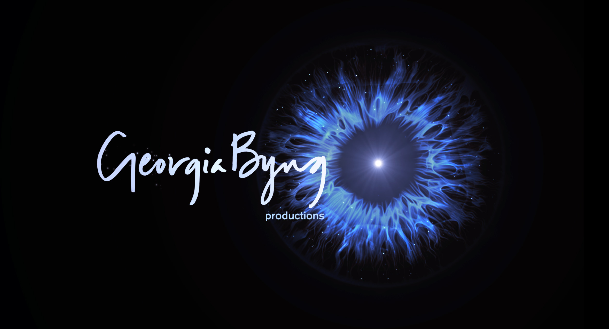


(size and prominence of all logos are on a favoured nations basis)

