Director Erik Leijonborg

Director Erik Leijonborg (born 1969) is one of Sweden’s most appreciated
directors. Leijonborg reached both the critics and the audience with
the nerve-racking TV miniseries Tusenbröder (2002) about three ordinary
working men turning bank robbers. Leijonborg has
worked on numerous successful films and TV-dramas.
Most recently he directed the TV period drama Selma
(2008) about the Swedish author and Nobel price winner
Selma Lagerlöf.

Biography

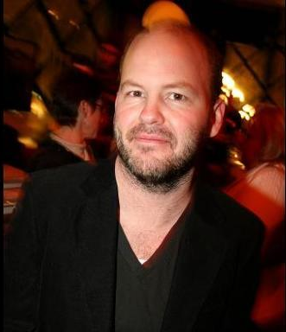

Erik Leijonborg, Director

Born: 1969-01-01

Projects last 10 years:
2010 Maria Wern Eyeworks/ TV4
2009 Livet i Fagervik SVT
2008 “Selma” SVT
“Främmande fågel” MOVIOLA/ TV4
“Om ett hjärta” SVT
2007 “Labyrint” SF/ TV4
2006 “Tusenbröder - Återkomsten” SVT/ Nordisk Film
“Moreno & tystnaden” SF/ TV4
2005 “Borkmanns punkt” SF/ TV4
2004 “Håkan Bråkan & Josef” SF
2003 “Talismanen” MOVIOLA/ TV4
2002 “Tusenbröder” II SVT
2001 “Tusenbröder” SVT
2000 “Brottsvåg” Jarowskij/ TV 5
1998 “Skilda världar” Grundy/ TV4

Awards (selected)
Prix Egalia Om Ett Hjärta -08
Kristallen Bästa Drama Tusenbröder -07
Aftonbladets TV pris Tusenbröder II -03
Prix Italia Finalist Tusenbröder II -03

