K-20: LEGEND OF THE MASK Production Notes
The Creators of ALWAYS -SUNSET ON THIRD STREET Bring Japan’s Favorite Supervillain to Movie Screens
Source: NTV (Nippon Television Network)
Official Movie Site: K-20
Production Notes translated by Jason Gray

A SciFi JAPAN EXCLUSIVE
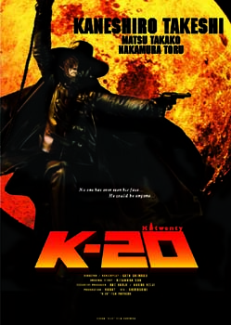
The large scale action adventure film K-20: LEGEND OF
THE MASK opens this weekend in Japan. International
promotional art courtesy of NTV. © 2008 “K-20″ Film
Partners
No one has ever seen his face… He could be anyone…
Editor’s Note: Last month I visited the American Film Market 2008 in Santa Monica, CA to see some of the latest films from Japan. Among the screenings I attended was the world premiere of K-20: LEGEND OF THE MASK (K-20: Kaijin Niju-Menso Den), a great action adventure film set in an alternate reality version of 1949 Tokyo.
The film was produced by Nippon Television Network (NTV), Robot Communications, and Toho, and stars Asian superstar Takeshi Kaneshiro (RETURNER, RED CLIFF) as a circus acrobat who is framed by a mysterious Batman/Shadow-like villain. Toho is opening K-20 in theaters across Japan this weekend, while NTV is handling sales of the movie to foreign buyers.
NTV has provided images and English language production notes for K-20: LEGEND OF THE MASK. SciFi Japan is pleased to present this early look at the film, and we also invite our readers to check out the recent coverage of NTV’s upcoming adaptation on Osamu Tezuka’s MW and keep an eye out for our reports on the new disaster film 252: SIGNS OF LIFE (252: Seizonsha Ari) and Toho/NTV’s blockbuster sci-fi epic 20TH CENTURY BOYS (20 Seki Shonen).
SPOILER WARNING: This article contains plot details for a new movie.

INTRODUCTION
Twenty years in the making! Beyond the expectations of the Japanese film world… an action spectacular is born!
Starring Takeshi Kaneshiro, the legend of “The Fiend With Twenty Faces”, Japan’s favorite supervillain comes to movie screens. Now, a story of heroic and zestful adventures begins… K-20: LEGEND OF THE MASK!
Nippon Television, the company that brought to you the mega hit title DEATH NOTE and whose ALWAYS -SUNSET ON THIRD STREET films moved audiences across Japan, and ROBOT, the country’s leading film production company, have teamed up again to produce a completely original action entertainment spectacular! Known to all of Japan, the character of The Fiend With Twenty Faces is the central figure in this thrilling story based on the novel by Soh Kitamura.
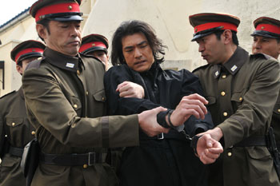
Circus acrobat Heikichi Endo (Takeshi Kaneshiro, center) is accused of being the
master criminal K-20. Photo courtesy of NTV. © 2008 “K-20″ Film Partners
Taking on the lead role of Heikichi Endo is Takeshi Kaneshiro, an internationally recognized actor consistently cast in the biggest films produced in Asia. Playing heroine Duchess Yoko Hashiba is Takako Matsu, one of Japan’s most sophisticated and respected actresses. In the role of the cool antagonist is Toru Nakamura, an actor who commands audience attention. They are surrounded by a sterling cast of consummate performers, including Jun Kunimura, Reiko Takashima, Kanata Hongo, Yuki Imai, Toru Masuoka and Takeshi Kaga.
Acclaimed writer-director Shimako Sato’s UK/Japan co-production TALE OF A VAMPIRE (1992) won the Avoriaz Prize at the Tokyo International Fantastic Film Festival. She also directed the WIZARD OF DARKNESS (Eko Eko Azarak) horror-fantasy films, wrote the screenplay for box office hit UNFAIR: THE MOVIE (2007) and has directed popular TV dramas and award-winning video game cinematics.
K-20: LEGEND OF THE MASK’s dynamic and original screenplay is brought to reality with an incredible “retro futuristic” world constructed by a team of Japan’s best special effects artisans. The amazing visuals of the work of the hot VFX company SHIROGUMI (ALWAYS -SUNSET ON THIRD STREET). Contributing to the screenplay and supervising the visual effects is ALWAYS director Takashi Yamazaki (RETURNER). The feature is full of exciting action adventures with a sense of mystique and wonder. It’s a movie like you’ve never seen before!
Naoki Sato composed the film’s soundtrack, and supplying the theme song “The Shock of the Lightning” is famed UK rock band Oasis, hailed as the “modern day Beatles”.
The incredibly talented cast and crew make K-20: LEGEND OF THE MASK an action spectacular not to be missed!

STORY
The Fiend (Kaijin) With Twenty Faces – Phantom Thief
In an alternative Tokyo, not like we know…
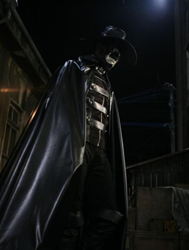
Rampo Edogawa’s The Fiend With Twenty Faces. © 2008
“K-20″ Film Partners
K-20: LEGEND OF THE MASK is set in the fictional Japanese capital of Teito, in 1949. World War II has been avoided. The system of “nobility” established in the Meiji Era (mid-late 19th century) continues, creating an extreme divide between the upper and lower classes. 90% of the country’s wealth is controlled by the upper members of society.
Teito has been gripped by the emergence of a phantom thief who steals priceless objects from the rich. He is known as “The Fiend (Kaijin) With Twenty Faces” or simply “K-20″.
Before he realizes it, he’s fallen into K-20’s trap
The protagonist of the story is Heikichi Endo, a circus acrobat who is deceived by K-20 and set up to take the fall for the phantom thief. Using his incredible physical dexterity, Heikichi wages war against K-20 to prove his innocence. He fights alongside K-20’s next wealthy target, Duchess Yoko Hashiba, and her husband-to-be, brilliant detective Kogoro Akechi. But what is the ultimate decision Heikichi has to make?
Disguising himself as K-20 to catch K-20
And so, Heikichi’s breathless pursuit begins, unfolding into an epic battle. Will falsely charged Heikichi finally be able to clear his name? You’re in for the most unpredictable shock at the end of the movie!

CHARACTERS
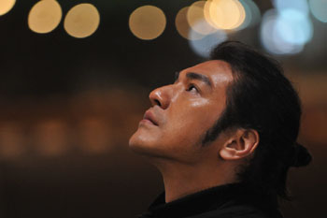
Takeshi Kaneshiro as Heikichi Endo. Photo courtesy of NTV. © 2008 “K-20″
Film Partners
Heikichi Endo (Takeshi Kaneshiro): A brilliant circus acrobat who is set up by K-20. In order to prove his innocence, he disguises himself as the phantom thief to track down the real K-20.
Star Takeshi Kaneshiro is one of the hottest actors in Asia whose exciting career is followed by fans around the world. His credits include CHUNGKING EXPRESS (Chung Hing Sam Lam, 1994), HERO (Ma Wing Ching, 1997), RETURNER (Ritana, 2002), HOUSE OF FLYING DAGGERS (Shi Mian Mai Fu, 2004), ACCURACY OF DEATH (Suwito Rein: Shinigami no Seido, 2008), and RED CLIFF (Chi Bi, 2008).
Detective Kogoro Akechi (Toru Nakamura): The calm and cool detective is K-20’s worthy opponent. With high social standing and a prestigious career, Akechi is popular among the masses. He is also engaged to Duchess Yoko Hashiba.
Actor Toru Nakamura has starred in the television series UMIZARU (2005) and the feature films GEN-X COPS (Dak Ging San Yan Lui, 1999), 2009: LOST MEMORIES (2002), HANA (2003), LIMIT OF LOVE: UMIZARU (2006), and SHAOLIN GIRL (Shorin Shojo, 2008). He will be seen next year in the comedic drama OPPAI VOLLEYBALL (Oppai Bare).

Duchess Yoko Hashiba (Takako Matsu) tries to unlock the mystery of K-20. Photo
courtesy of NTV. © 2008 “K-20″ Film Partners
Yoko Hashiba (Takako Matsu): Duchess Yoko Hashiba is the heir to Hashiba Enterprises, and K-20’s next target. After she’s threatened by K-20, Heikichi rescues her, gaining both her and Akechi’s support.
Called “the most recognized actress in Japan”, Takako Matsu has appeared in the television series, TV movie, and theatrical film versions of HERO, as well as the films THE HIDDEN BLADE (Kakushi Ken Oni no Tsume, 2004), BRAVE STORY (2006), SUITE DREAMS (Uchoten Hoteru, 2006), and TOKYO TOWER: MOM AND ME, AND SOMETIMES DAD (Tokyo Tawa: Okan to Boku to, Tokidoki, Oton, 2007).
Genji (Jun Kunimura): A master prop-maker at the circus and Heikichi’s closest ally.
Jun Kunimura’s extensive list of movie credits includes AUDITION (Odishon, 1999), ICHI THE KILLER (Koroshiya 1, 2001), KILL BILL VOL 1 (2003), GODZILLA: FINAL WARS (2004), LORELEI: THE WITCH OF THE PACIFIC OCEAN (Lorelei, 2005), SINKING OF JAPAN (Nihon Chinbotsu, 2006), and THE LAST PRINCESS (Kakushi Toride no San Akunin: The Last Princess, 2008).
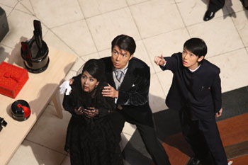
Yoko Hashiba, Detective Kogoro Akechi (Toru Nakamura), and his assistant Yoshio
Kobayashi (Kanata Hongo) spot an unexpected guest. Photo courtesy of NTV.
© 2008 “K-20″ Film Partners
Kikuko (Reiko Takashima): Genji’s wife. Retired now, she was a brilliant swindler. Along with Genji she lends Heikichi support.
Yoshio Kobayashi (Kanata Hongo): Kogoro Akechi’s assistant. He works to uncover the truth about K-20.
K-20: With over twenty different disguises, K-20 is a master phantom thief whose true identity is unknown.
Shinsuke (Yuki Imai): One of the circus kids. He looks up to Heikichi like an older brother.
Mystery Man (Takeshi Kaga): The man who hires Heikichi to take secret photos of the engagement ceremony between Akechi and Yoko.
Takeshi Kaga is well known as the flamboyant host of TV’s IRON CHEF. He has also appeared in the films ULTRAMAN ZEARTH (Urutoraman Zeasu, 1996), SAMURAI COMMANDO: MISSION 1549 (Sengoku Jieitai 1549, 2005), DEATH NOTE (Desu Noto, 2006), DEATH NOTE II: THE LAST NAME (Desu Noto II, 2006), and MONKEY MAGIC (Saiyuki, 2007).
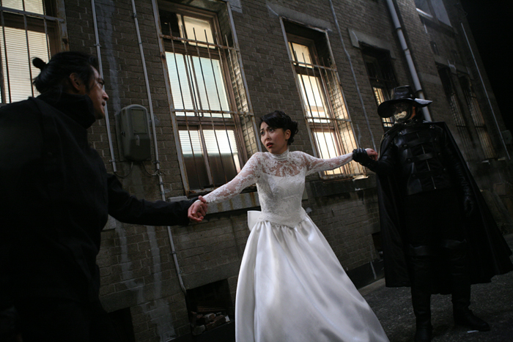
Yoko Hashiba is caught in a tug of war between Heikichi Endo and K-20. Photo courtesy of NTV. © 2008 “K-20″ Film Partners

PRODUCTION NOTES
Read by 100 million people!
Literary master Rampo Edogawa is the father of mystery novels in Japan. Rampo’s perennially best selling 26-volume Boy Detectives series launched in 1936. Spanning 26 years, it was serialized in pre and post-WWII youth magazines.
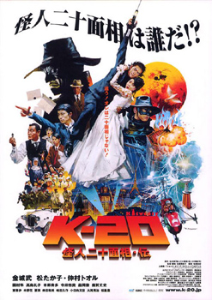
Japanese poster art. © 2008 “K-20″ Film Partners
Rampo’s character of The Fiend With Twenty Faces is a master of disguise and a phantom thief whose true identity is a mystery. Almost as if by magic, he is able to infiltrate highly secure locations to steal priceless objects. His crimes are as theatrical as they are daring. The breathtaking battles between Detective Kogoro Akechi and The Fiend With Twenty Faces provided thrilling, page-turning excitement for children at time when other forms of amusement were limited and before the advent of TV.
In the 70 years since their first publication, these stories have been “read by 100 million people” (POPLAR Publishing). As national best sellers, they will continue to be passed on to each new generation.
The Fiend With Twenty Faces, The Novel
Published in 1989, playwright Soh Kitamura’s The Fiend With Twenty Faces attracted a lot of attention for changing the true identity of the legendary character. While retaining the basic back story of the original classic, Kitamura’s completely new take on the tale caused an uproar among Rampo Edogawa’s huge number of fans.
On the set of the film, Kitamura commented: “When I was a kid, I always wondered what The Fiend With Twenty Faces was doing when he wasn’t in disguise. I had long thought I would write his biography when I grew up”. Kitamura himself makes a cameo near the beginning of the film in the scene where K-20 first appears.
The crew of ALWAYS -SUNSET ON THIRD STREET reunites!
The crew behind multiple Japan Academy Prize-winning film ALWAYS -SUNSET ON THIRD STREET reteam for K-20: LEGEND OF THE MASK. ALWAYS director Takashi Yamazaki passes the baton to director Shimako Sato while cooperating on the screenplay and overseeing the visual effects.

The distant towers of the upper class stand in stark contrast to the slums of the
Japanese capital city of Teito. Photo courtesy of NTV. © 2008 “K-20″ Film Partners
Sato commented on the collaboration: “It’s a fantastic crew. Everyone possesses such great skill. Takashi Yamazaki designed the Imperial Tower and blimp you see in the opening sequence. In the screenplay, he assisted with some of Heikichi’s dialogue in scenes where he was angry, or embarrassed (laughs). He also contributed the line ‘Now, let the circus begin’ in the final scene”.
Using VFX to create the city of “Teito” in the opening sequence
There are several differences between K-20: LEGEND OF THE MASK and Soh Kitamura’s original novel. In particular, the novel is set in pre and post-WWII Tokyo. With Kitamura’s blessing, we instead created the fictional city of “Teito” with the action taking place in 1949, “in a past where World War II never happened”. The Tokyo of an alternate universe, so to speak.
“The opening sequence is important because it leads audiences into the world of the film,” explains producer Shuji Abe. In K-20: LEGEND OF THE MASK, the incredible aerial flyover of Teito that opens the film pulls viewers in.
The visual effects in K-20: LEGEND OF THE MASK were created by SHIROGUMI, the wizards behind the recreation of 1950s Tokyo in the ALWAYS films. The opening shot alone required three months of production work. Each building and house had to be meticulously rendered one at a time.
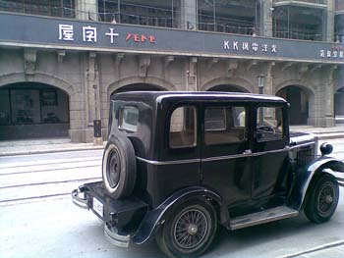
K-20: LEGEND OF THE MASK also featured elaborate period sets, vehicles
and props. © 2008 “K-20″ Film Partners
Visual effects director Kiyoko Shibuya explains the process: “The city has five different zones we had to create, including the port, the slums, the factory district and the downtown core. Each zone took a lot of time and effort to build. In total, there must be tens of thousands of buildings in the scene.”
The stunning sequence also shows trains running down below and blimps and gyrocopters in the sky. “The team that created the ALWAYS films has outdone themselves with this sequence,” claims director Shimako Sato.
Astounding action and “Parkour”
As Heikichi holds onto Yoko, the pair zoom into the air effortlessly on a wire in an action scene with a dynamic sense of speed. In K-20: LEGEND OF THE MASK the cast members attempted their own wire stunts, through a combination of human power and special equipment. Star Takeshi Kaneshiro has experienced shooting films in the homeland of action moviemaking – Hong Kong and China – but even he was deeply impressed with the high level of skill the Japanese action team exhibited.
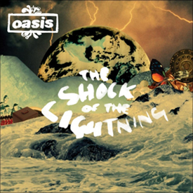
The British rock band Oasis provide the theme song for K-20:
LEGEND OF THE MASK. © 2008 Creation Songs Ltd./ Sony
Music Publishing
In addition to wires, director Shimako Sato wanted to employ the techniques of “parkour”, using the sequence from Casino Royale as a reference. Parkour is the art of moving as quickly and efficiently as possible through an environment and overcoming obstacles in one’s path, without the use of any tools. The technique originated from France but the action team employed two parkour practitioners (”traceurs”) from Russia. Whether scaling iron towers or leaping across rooftops, the super-human abilities that Heikichi acquires in the film were shot with live performers, without any use of CG.
“In movie scenes up until now, it’s generally been a regular person against a traceur. I wanted to shoot action scenes with two traceurs battling each other, which was one reason I made this film,” explains Sato. The lightning fast action will keep audience’s eyes glued to the screen!
Oasis sing for K-20: LEGEND OF THE MASK!
Hailed as the “modern day Beatles”, internationally famous British rock band Oasis provide the theme song for K-20: LEGEND OF THE MASK. “The Shock of the Lightning” is the lead track from their chart-topping album “Dig Out Your Soul”, released in October of 2008.
Having studied overseas at the London International Film School, director Shimako Sato comments: “When I made my feature directing debut in the UK back in 1992 or 93, there were rumours around London of an incredible new band on the scene. That band was Oasis. For me to reconnect with their music in this way is an honour.”

COMMENTS FROM THE CREATIVE TEAM
Shuji Abe – Executive Producer (President, ROBOT Communications)
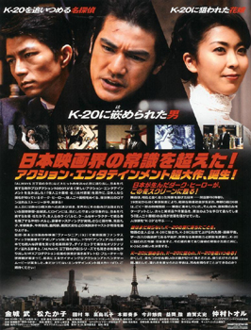
Japanese advert featuring stars Toru Nakamura, Takeshi
Kaneshiro, and Takako Matsu. © 2008 “K-20″ Film Partners
Roughly twenty years have passed since I first came across the original novel at a bookstore in Shinjuku. I clearly remember the exact store I bought it at because the book made such an impact on me. When I first saw the title The Fiend With Twenty Faces I was certain it was the work of author Edogawa Rampo until I noticed the subheading “The Legend”. The author was in fact playwright Soh Kitamura. The character of The Fiend With Twenty Faces had originally appeared in the Boy Detectives series, which were must-read books for children of my generation.
When Kogoro Akechi would face off against villain The Fiend With Twenty Faces, it was thrilling. The books captured the era of the 1950s with realistic storytelling that jumped off the page. After reading them, if you took a walk in the town at night and passed a dim street lamp, you would wonder whether The Fiend was lurking in the shadows.
For readers, empathy lies with the always righteous Kogoro Akechi while the character of The Fiend With Twenty Faces is an ominous figure that embodies evil. When I picked up Kitamura’s novel, I was expecting the same kind of depiction, but I was instead struck by how fresh his approach was in portraying The Fiend With Twenty Faces as a human being. Furthermore, how could a character always upholding justice like Akechi be made so villainously cunning?
In this novel, the true identity of The Fiend With Twenty Faces is that of an ex-circus performer – in other words, someone of the masses. I felt the backdrop of the dark streets of Tokyo in the early Showa period coupled with the ultra-realistic storytelling greatly lent itself to cinema. I knew instantly that I wanted to adapt the novel into a film.
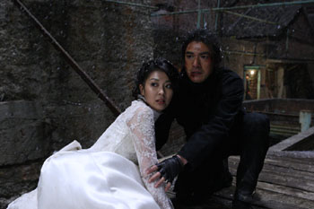
Heikichi comes to Yoko’s rescue. Photo courtesy of NTV. © 2008 “K-20″ Film
Partners
At that time, ROBOT Communications and I personally had absolutely no experience in producing feature films. Nevertheless, I was desperate to do something so I immediately made an appointment to meet with Mr. Kitamura, traveling to Nagoya where he was rehearsing a new play of his. I had visualized everything so completely in my mind that I felt ready to start shooting the next day. But first I had to inquire whether I could option the rights to his novel. Looking back now it was a bit reckless on my part, but we were both twenty years younger. Then as now, I freely told Mr. Kitamura why I wanted to adapt his novel into a film. Amazingly, I was able to acquire the rights without objection. In retrospect, it was quite odd as there were no written contracts. It all happened very easily, with Mr. Kitamura basically saying “sure, go ahead”, almost as if it was my reward for going all the way to Nagoya to see him.
In 1990 ROBOT was still four years away from entering the feature film market. When it came to producing movies I didn’t know right from left but forged ahead with preparations for the adaptation. After much trial and error the movie didn’t end up getting produced, but my strong passion to realize the project remained.
In 1994 we boldly entered the film world with Shuji Iwai’s LOVE LETTER. In the fifteen years since we have produced 31 films. During that time I visited Nagoya on around three occasions to reiterate our desire to make the film, to which Mr. Kitamura would sympathetically respond “I can wait patiently”. Soon after, The Fiend With Twenty Faces was republished and in the afterword was written “There’s been talk of a film adaptation for a while now, but I wonder when it will become a reality”. We took it as a light jab at our sluggish progress.

Duchess Yoko Hashiba wears black for her engagement party to Detective Kogoro
Akechi. Photo courtesy of NTV. © 2008 “K-20″ Film Partners
In 2005 and 2007 we recreated the 1950s in the film ALWAYS -SUNSET ON THIRD STREET and its sequel using cutting edge visual effects (VFX) technology which became the talk of the film world. Our success greatly helped us move closer to realizing The Fiend With Twenty Faces. VFX are an indispensable tool for creating the world of the story on screen. Twenty years ago it wouldn’t have been possible to achieve this film.
All the right conditions finally fell into place and shooting began in January of 2008. It was a long road to get there but in some way Mr. Kitamura’s words about “being patient” helped us persevere. We believe we’ve brought The Fiend With Twenty Faces to the screen with great respect for the source material, boldly dramatizing the story over two and a half hours. We chose to give the film the unique title K-20: LEGEND OF THE MASK. Mr. Kitamura consented to this and gave us his support.
Twenty years from conception, K-20: LEGEND OF THE MASK will be our 32nd film to reach the screen. To say that this film was our true starting point is not saying enough. In a certain way, it’s our “first film”. Mr. Kitamura, what are you thoughts? We hope you think it was worth the twenty-year wait.
Seiji Okuda – Executive Producer (Nippon Television – Contents Division Executive Producer)
In elementary school I used to receive a new The Fiend With Twenty Faces book every Christmas. I treasured them. When Shuji Abe came to me with this project those memories were the first thing I thought of.
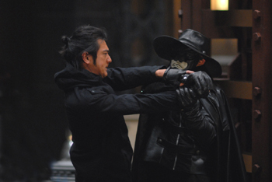
Heikichi Endo battles the villain who framed him. Photo courtesy of NTV.
© 2008 “K-20″ Film Partners
In Japan, superhero movies haven’t been produced for a long time. In Hollywood you find Spider-Man and Batman, but here the same type of heroes don’t exist. Reviving the superhero tradition in Japan with K-20: LEGEND OF THE MASK is something that gives me great pleasure. Adapting Soh Kitamura’s fresh interpretation of “The Fiend With Twenty Faces”" was in itself an intriguing idea and more than anything, the idea of resurrecting this once tremendously popular character in 2008 is something I believe is of great significance.
In reassembling the team behind ALWAYS -SUNSET ON THIRD STREET, combined with the skill of writer-director Shimako Sato, cutting edge visual effects and strong drama, K-20: LEGEND OF THE MASK has truly become an impressive achievement. One element that I greatly looked forward to personally was what kind of world the fictional city of “Teito” would be. Perhaps we really would’ve lived in those kinds of circumstances if WWII had never happened. In Teito there is a great divide between the wealthy and the poverty-stricken. This is similar to the situation in today’s Japan, so I believe we can empathize with a character like K-20 who defends the weak and defeats the strong.
Showing audiences K-20: LEGEND OF THE MASK feels very similar to the time we presented the first ALWAYS film to the world. I’m extremely excited to see what kind of reaction audiences will have. I believe that we’ve made a film to be proud of, so I’m certain that audiences will feel the same way.
Shimako Sato – Writer & Director
Through the efforts of the entire crew, the screenplay became a movie beyond my imagination. It may say sound strange to say it myself, but I’m amazed at the budget we had, the level of craftsmanship, and how entertaining the final film is. As someone who loves big mainstream movies it’s always been a dream of mine to make a film like this, so I’m extremely happy I was able to direct K-20: LEGEND OF THE MASK.
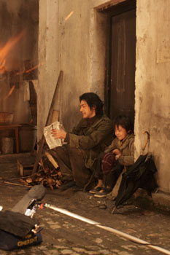
Heikichi uses some slight of hand to make a baked
potato dinner for Shinsuke (Yuki Imai). Photo
courtesy of NTV. © 2008 “K-20″ Film Partners.
This is the third production I’ve made featuring the character of Kogoro Akechi and I had also previously worked on a number of screenplays featuring another famous Japanese detective, Kosuke Kindaichi, but K-20: LEGEND OF THE MASK was by far the most challenging.
At first, the screenplay followed the novel closely but with the permission of Soh Kitamura and Rampo Edogawa’s grandson Kentaro Hirai it became more of a high-flying action drama. Rather than concentrating on whether to remain faithful to the novel or include original elements, I aimed to write an entertaining story.
Takeshi Kaneshiro is the type of actor who likes engaging in discussions with the director when he makes a film. We both had a similar view of how the character of Heikichi should be played and had a great rapport.
Although it’s the tale of a hero, I didn’t want the character to only be handsome and dashing. When Takeshi Kaneshiro asked me whether Heikichi was “cool or funny” I immediately said “funny!” A lot of his ideas and improvisations made their way into the movie. Takeshi Kaneshiro made the character his own as only he could.
What I wanted to express with this movie was that no matter how unfortunate a situation may seem, if people think positively they can lead a happier life. Heikichi Endo is my ideal character because he embodies this belief.
K-20: LEGEND OF THE MASK couldn’t have been made in Hollywood. It’s an original movie that could only come from Japan and I believe it’ll entertain audiences in a way they haven’t experienced before. From children to the baby boom generation who grew up with The Fiend With Twenty Faces, I hope people everywhere enjoy it.

K-20: LEGEND OF THE MASK
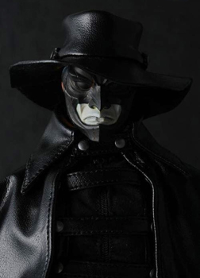
At closeup look at Medicom’s new K-20 figure. © 2008 “K-20″
Film Partners/Medicom Toy Corporation
2008 / 137 min / Color
Screen Size 1:1.85
AFM Screening: Friday, November 7, 8:30am at AMC Loews Broadway 2, Saturday, November 8, 7:00pm Fairmont 3
Japanese Theatrical Release: Toho, December 20, 2008
International Sales: Nippon Television Network Corporation
Cast:
Takeshi KANESHIRO
Takako MATSU
Toru NAKAMURA
Staff:
Director / Screenplay: Shimako SATO
Original Story: Soh KITAMURA
Executive Producer: Shuji ABE/ Seiji OKUDA
Production: ROBOT
VFX: SHIROGUMI
© 2008 “K-20” Film Partners

